Ideation Phase
Brainstorm & Idea Prioritization Template

Date | 31 January 2025
Team ID
  SWTID-2026-6064
Project Name | Streamlining IT Procurement: Automating Standard Laptop Orders with Flow Designer
Maximum Marks | 4 Marks

Brainstorm & Idea Prioritization Template:
Brainstorming is used to generate multiple possible solutions for the identified IT procurement problem. The team explores different ways to reduce manual work, avoid delays, and ensure that approved standard laptop requests are quickly assigned to the Hardware team.
Step-1: Team Gathering, Collaboration and Select the Problem Statement
Selected Problem Statement
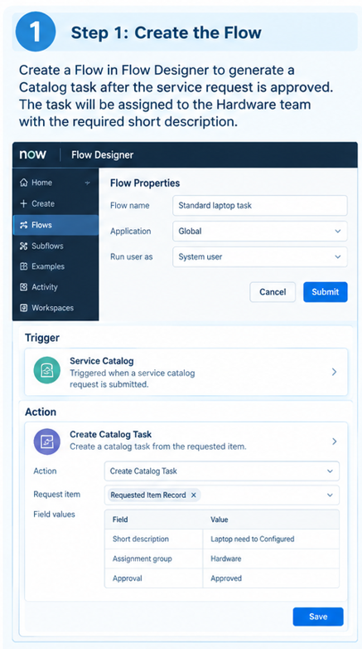

Step-2: Brainstorm, Idea Listing and Grouping
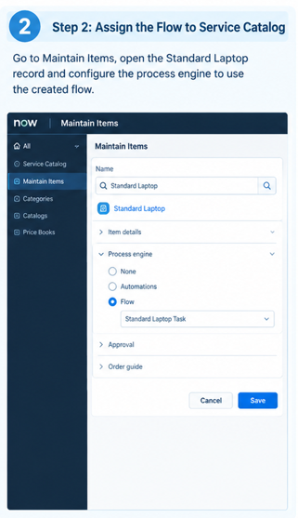
Step-3: Idea Prioritization
